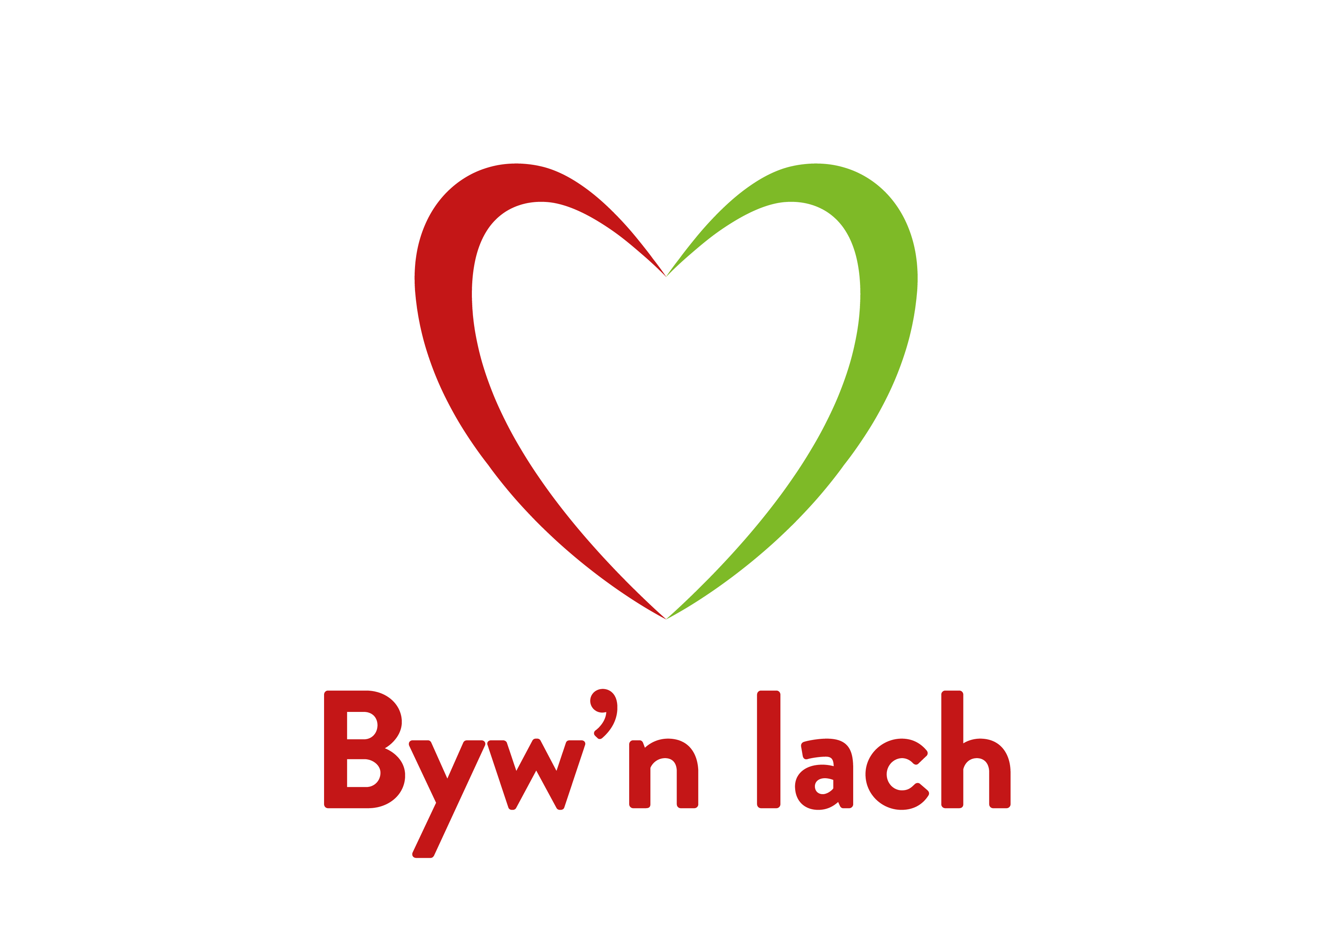
Excellence card: APPLICATION FORM

Personal Details
Title |  |  |  |  | Name |  |  |  |  |  | Surname
Address
Postcode |  |  |  |  |  |  |  |  |  |  |  | e-mail
Tel |  |  |  |  |  |  |  |  |  |  |  | Mobile
D. O. B. |  |  |  |  |  |  |  |  |  |  |  | Age
Club Name

Your Sport / Squad Training
In what Sport have you gained honours?
Is your National Governing Body (NGB) recognised by the Sports Council for Wales? |  |  |  |  |  |  |  |  |  |  |  |  |  |  |  |  | Yes |  |  |  |  |  |  |  | No
Are you a member of any National Squad for your Sport |  |  |  |  |  |  |  |  |  |  |  |  |  |  |  |  | Yes |  |  |  |  |  |  |  | No

Please specify

Your Achievements
Representation in the last 12 months (refer to guidelines for the criteria)
Event / Fixture |  |  |  |  |  |  | Venue |  |  | Date |  |  |  |  |  |  |  |  | Achievement
Championship ranking in the last 12 months (refer to guidelines for criteria) - if appropriate
Event / Fixture |  |  |  |  |  | Venue |  |  | Date |  |  |  |  |  |  |  |  | Ranking

Declaration
The information provided in this form is true and accurate to the best of my knowledge.
I agree to abide by all of the conditions set out in this application pack. Parental/Guardian Signature also required for applicants under 16 years of age.
Signed (applicant) |  |  |  |  |  |  |  |  |  |  |  |  |  |  |  |  |  |  |  |  |  | Date
Parent/Guardian

Checklist

If you fail to include any of the items below your application will be returned.
Have you kept a copy of the application for yourself?
Have you paid? £10 payable to Byw’n Iach
Sort Code 20-35-70
Account Number 20852414
Reference Use RHG & name of applicant

Governing Body Reference

Details of Regional Development Officer or a Sport Specific Development Officer of the relevant National Governing Body who can be contacted to validate your application
Name |  |  |  |  |  |  |  |  |  |  |  |  | Surname
NGB |  |  |  |  |  |  |  |  |  |  |  |  | Position in NGB
Tel |  |  |  |  |  |  |  |  |  |  |  |  | Email

Please e-mail this form to: alunjones2@bywniach.cymru

Partnership Unit Manager, Byw’n Iach Arfon
Ffordd Bethel, Caernarfon, Gwynedd LL55 1HW

